**Business Problem:**

Forecast the CocaCola prices data set. Prepare a document for each model explaining how many dummy variables you have created and RMSE value for each model. Finally which model you will use for Forecasting.

**Data:**

Data has Quarter and Sales and converted into Time Series.

**Pre-processing Data:**

There was no outlier and NA in the data. Divide them with frequency 4 because an year has 4 quarters. Partition the dataset 1:38 and last four (39:42 – means year) we have to predict it.So last four is test dataset.

**Building the Model:**

Build the model for Time Series.

**Visualization:**

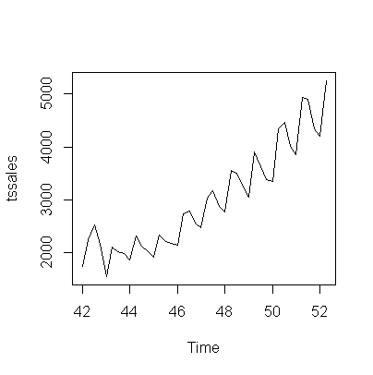

**Using HoltWinter function:**

Training the model using alpha = 0.2, beta =F and Gama =F and predict it and Map it.

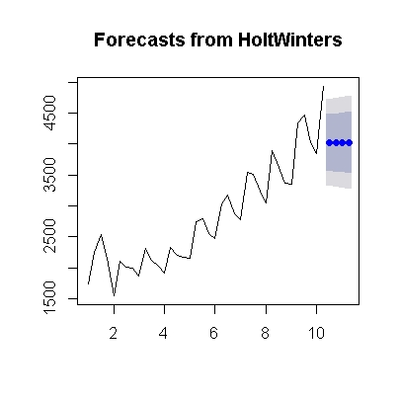

Mapping value : 16.634

Training the model using alpha = 0.2, beta =0.15 and Gama =F and predict it and Map it.

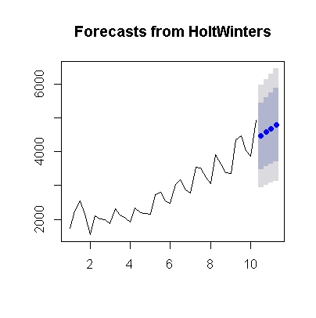

Mapping value : 8.7477

Training the model using alpha = 0.2, beta =0.15 and Gama =0.05 and predict it and Map it.

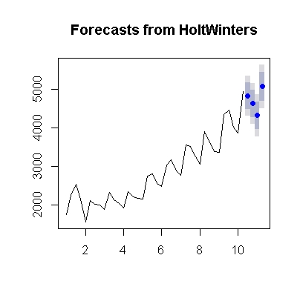

Mapping value: 3.5841

Training the model using beta =F and Gama =F and predict it and Map it.

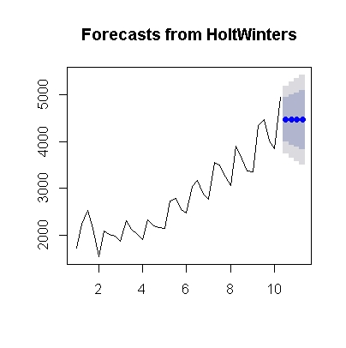

Mapping value: 9.0930

Training the model using Gama =F and predict it and Map it.

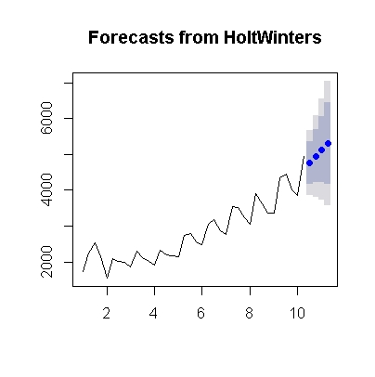

Mapping value: 8.627

By running with only train dataset:

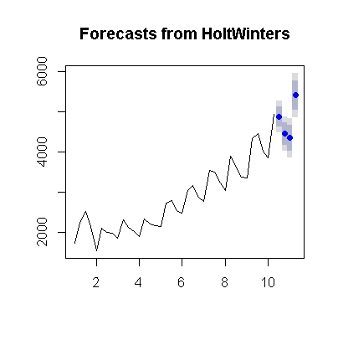

Mapping value: 2.3972

**RMSE Values for different models:**

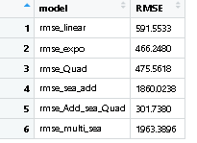

**Summary of the model:**

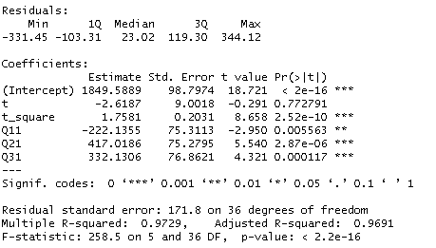

**Business Problem:**

Forecast the Airlines Passengers data set. Prepare a document for each model explaining how many dummy variables you have created and RMSE value for each model. Finally which model you will use for Forecasting.

**Data:**

Data has Month and Passenger and converted into Time Series.

**Pre-processing Data:**

There was no outlier and NA in the data. Divide them with frequency 12 because a year has 12 months. Partition the dataset 1:84 and last four (85:96 – means year) we have to predict it. So last 12 are the test dataset.

**Building the Model:**

Build the model for Time Series.

**Visualization:**

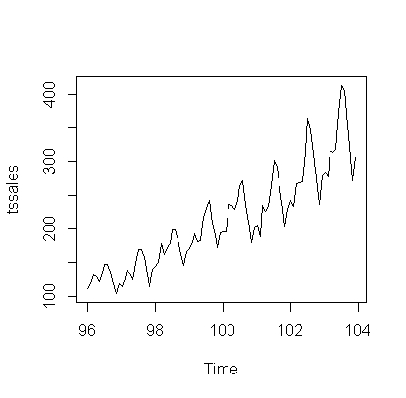

**Using HoltWinter function:**

Training the model using alpha = 0.2, beta =F and Gama =F and predict it and Map it.

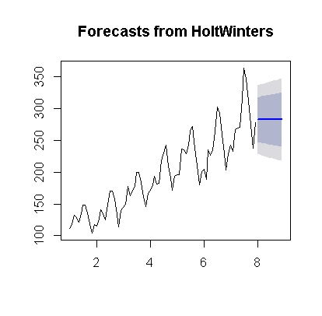

Mapping value: 17.23

Training the model using alpha = 0.2, beta =0.15 and Gama =F and predict it and Map it.

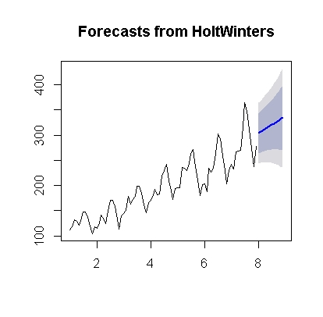

Mapping value : 11.216

Training the model using alpha = 0.2, beta =0.15 and Gama =0.05 and predict it and Map it.

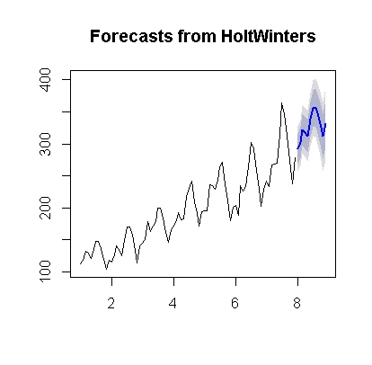

Mapping value: 7.256

Training the model using beta =F and Gama =F and predict it and Map it.

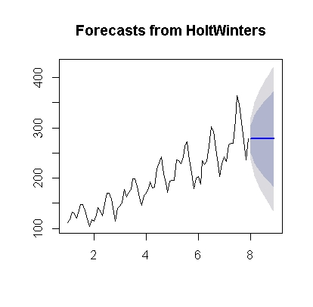

Mapping value: 18.555

Training the model using Gama =F and predict it and Map it.

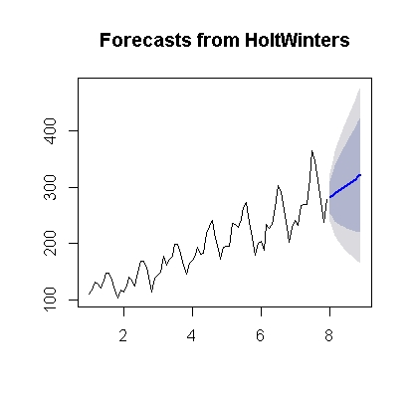

Mapping value: 13.104

By running with only train dataset:

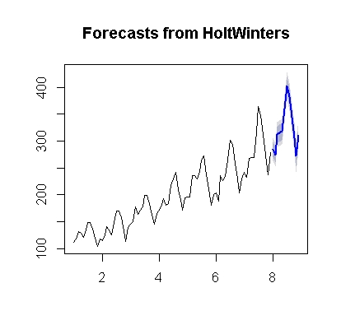

Mapping value: 1.7308

**RMSE Values for different models mention in table :**

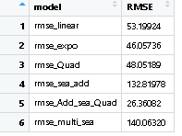

Summery details of model:

